SPRINT-2

|  |  |
| --- | --- |
| **TEAM ID** | **PNT2022TMID42671** |
| **Project Name** | **IoT Based Smart Crop Protection System For Agriculture** |
| **Maximum mark** | **20 marks** |

**Description:**

Receiving the data from IOT devices to IBM Watson IOT platform and connected to Node Red for the Data visualization.

**Device Credentials:**

Organization ID: dswbln

Device Type: Crop_Protector

Device ID: 12345678

**Output: IBM IOT Platform**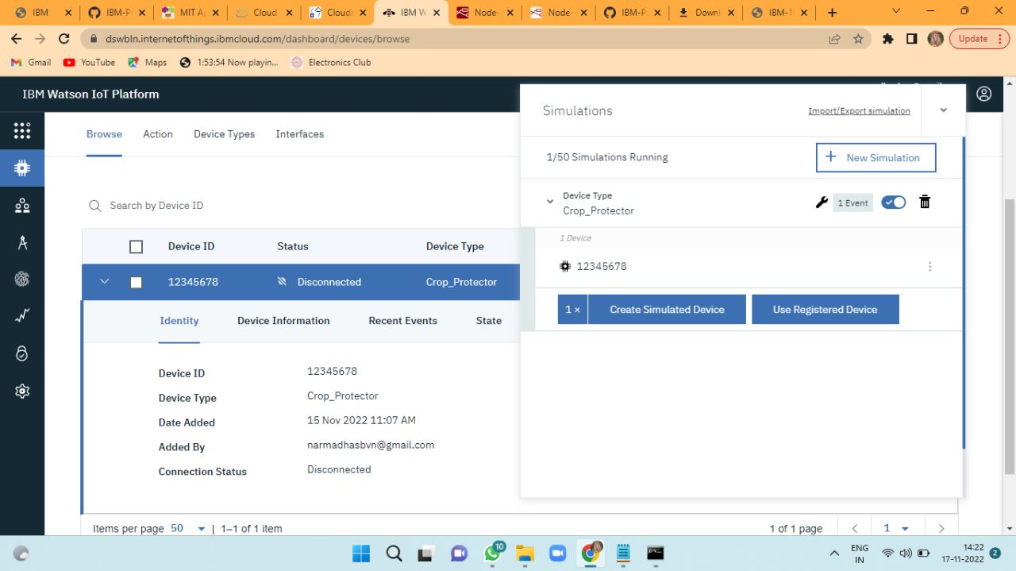

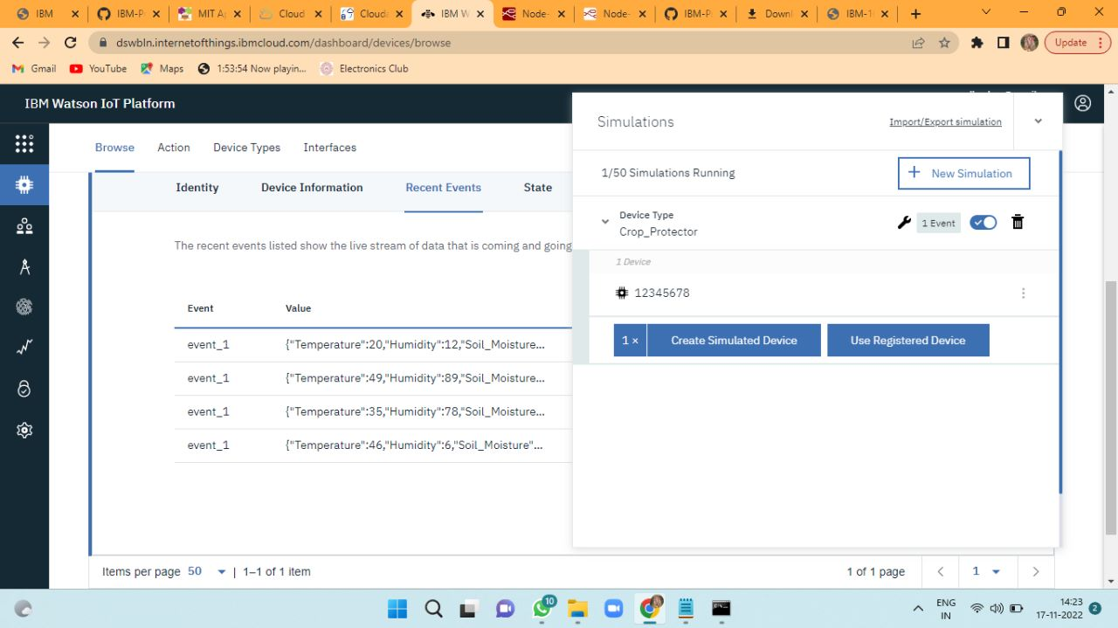

**Node Red**

